**RESEARCH PAPER - 1**

**CONTRASTING THE EFFICIENCY OF XCEPTION AND VGG19 IN IMAGE RECOGNITION FOR DEFECTS CAUSED BY DRILLING MACHINES**

Rohith Abishua J, Dr M Pethuraj

Rohith Abishua J ,

Research Scholar,

Department of Computer Science Engineering,

Saveetha School of Engineering,

Saveetha Institute of Medical and Technical Sciences,

Saveetha University, Chennai, Tamil Nadu. India. Pincode: 602105.

rohithabishuaj0179.sse@saveetha.com

Dr M Pethuraj,

Project Guide, Corresponding Author,

Department of Autotronics,

Saveetha School of Engineering,

Saveetha Institute of Medical and Technical Sciences,

Saveetha University, Chennai, Tamil Nadu. India. Pincode: 602105.

[pethurajm.sse@saveetha.com](mailto:pethurajm.sse@saveetha.com)

**ABSTRACT**

**Aim:** This study work aims to improve the detection accuracy of surface defects caused by drilling machines, focusing on delamination in particular. A serious flaw that can jeopardize a material's structural integrity is delamination, which is especially problematic in industrial and aerospace applications. In order to assess how well two cutting-edge deep learning architectures, Xception and EfficientV2M, perform in identifying and categorizing delamination faults in surfaces caused by drilling machines, this study compares and contrasts them. The main objective is to research and determine the best model, taking into account variables like sensitivity, specificity, and overall precision, for precisely locating and classifying delamination flaws. We want to shed light on the advantages and disadvantages of these deep learning architectures in the context of surface defect identification, especially in the difficult field of delamination, by thoroughly analyzing them.

Keywords: surface defect detection, drilling machine-induced defects, delamination, structural integrity, industrial applications, aerospace applications, deep learning architectures, Xception, EfficientV2M, specificity, precision, defect recognition, material integrity, comparative analysis.

**INTRODUCTION**

The pursuit of improved accuracy and fault detection has become critical in the dynamic realm of manufacturing and industrial operations. More specifically, state-of-the-art technologies and approaches are needed for the identification of surface defects caused by drilling equipment, with a particular focus on delamination. Using cutting-edge computer vision techniques has become a viable way for companies to meet their goals of increased productivity and superior products. In this introduction, two well-known convolutional neural network (CNN) architectures—Xception and EfficientV2M—are examined as possible means of improving the precision of identifying surface defects caused by drilling machines, with a particular emphasis on the complex phenomenon of delamination. It is impossible to overestimate the importance of surface defect detection and mitigation, particularly in sectors where structural integrity and accuracy are critical. Although essential to production, drilling operations can unintentionally result in flaws like delamination, which is the separation of layers at the material contact. Accurately identifying and categorizing these flaws is essential to guaranteeing product quality, reducing waste, and improving overall operational effectiveness. The development of CNN architectures, which provide unmatched capabilities in image identification and classification, has completely transformed the area of computer vision. Two strong competitors in this space are EfficientV2M, an advancement of the EfficientNet family, and Xception, an extension of the Inception architecture. Xception is well known for its depth-wise separable convolutions, which enable it to successfully capture complex patterns and features. Conversely, EfficientV2M is praised for its exceptional computational resource efficiency, which makes it a desirable choice for real-time applications. The desire for greater precision is what motivates the investigation of these structures in relation to surface flaws caused by drilling, especially delamination. The intricacy and diversity of surface defect patterns are difficult for traditional approaches to handle, thus it's critical to take use of the capabilities of cutting-edge CNNs. This study compares Xception with EfficientV2M in an effort to determine which architecture is best at detecting the finer points of delamination, which will ultimately lead to a more robust and dependable defect detection system. The primary objective of the proposed study is to advance the state-of-the-art in fault identification in the manufacturing industry. Research and development is being driven by the need for accurate and quick defect detection as companies adopt automation and smart technologies more and more. The deliberate choice to concentrate on delamination takes into account both its complexity and possible effects on structural integrity. Preventing catastrophic failures in final goods and avoiding material waste are two important goals of accurate delamination detection, which protects human and economic interests.With a focus on delamination in particular, the combination of state-of-the-art CNN architectures—Xception and EfficientV2M—offers a viable path toward raising the accuracy of surface defect identification caused by drilling machines. The goal of this research is to further the ongoing discussion on how to use cutting-edge computer vision techniques in manufacturing to improve operational efficiency and quality control. In order to shed light on the effectiveness of these architectures in the context of defect recognition, the following sections of this study will examine the methodologies used, experimental setups, and comparative analyses. This will lay the groundwork for a thorough and insightful examination of each architecture's advantages and disadvantages.

**MATERIALS AND METHODS**

The primary objective of this study was to improve the accuracy of surface defect detection caused by drilling machines, with a particular emphasis on the complex process of delamination. In order to do this, Xception and EfficientV2M—two advanced deep learning architectures—were used in a thorough comparison examination. The research was conducted in an extremely controlled experimental setup, classifying flaws into holes that were not precisely drilled.

The study group, which was assigned to assess less-than-ideal drilled holes, and the control group, which was set aside for flawlessly drilled holes, were the two main groups that were formed. Cracks, delamination, and incomplete holes were all well defined subgroups within the research group, whereas precisely drilled holes were the only feature in the control group. The development of a solid dataset for the deep learning models' training, testing, and validation constituted the cornerstone of this study. A thorough selection of 900 photos was made in order to capture the nuances of drilling-induced surface imperfections. The full dataset was used in the training phase, which provided Xception and EfficientV2M models with a comprehensive grasp of drilling-induced defects. An 80-20 split was then implemented, dividing the dataset in half: 80% for testing and 20% for validation. The goal of this partitioning technique was to thoroughly assess the models' generalization skills on data that had never been seen before.

Examining the research group in detail, three subgroups were identified to reflect the subtleties of poorly drilled holes. In order to detect any fractures or structural instabilities brought on by the drilling operation, the first subgroup concentrated on cracks. The second subgroup focused on delamination, a difficult defect that requires high accuracy for effective identification since it involves the separation of layers inside the material. The third subgroup dealt with incomplete holes, describing situations in which the drilling operation was not completed. On the other hand, the control group gave the models a reference point and only included pictures of holes that were precisely drilled. This definite difference made it easier to improve the models' ability to detect minute differences unique to less-than-ideal drilled holes, with an emphasis on the subtleties of delamination.

In order to match the distinct properties of the dataset, the chosen deep learning architectures, Xception and EfficientV2M, were not only installed but also painstakingly adjusted during the training stage. By using the complete dataset for training, a thorough learning process was made possible, guaranteeing that the models could accurately represent the subtleties that were offered by the research and control groups. The next stages of testing and validation, which used 20% of the dataset each, were designed to thoroughly assess the models' capacity for generalization and their resilience in correctly detecting faults caused by drilling. The models were methodically exposed to a portion of the dataset that had not been used for training during the key testing phase. This acted as a yardstick for how well the models could apply newly learned lessons and correctly identify flaws in fresh, untested data. The validation stage served as a kind of double-check, guaranteeing that the models performed consistently across various dataset subsets and offering detailed insights into their dependability and broad applicability. Furthermore, in order to artificially enlarge the dataset during the training phase, the study employed advanced data augmentation techniques. This deliberate tactic subjected the models to a wide variety of drilling-induced flaws in an effort to strengthen their resilience and increase their ability to detect minute changes in surface conditions, particularly when delamination is present. The careful balancing act between computing efficiency and model complexity was largely dependent on the training parameter choices. The optimization techniques, learning rates, batch sizes, and other hyperparameters were carefully adjusted to provide the best possible convergence and reduce the possibility of overfitting. Extra regularization methods, such dropout, were carefully applied to improve the models' capacity to efficiently extrapolate from the training data to unknown cases.

Additionally, the study included a transfer learning impact analysis to see if pre-trained models on larger picture datasets may improve the models' performance in surface defect identification caused by drilling. The outcomes demonstrated a noticeable increase in accuracy and resilience, confirming the effectiveness of utilizing prior information contained in the weights of the models. This result emphasizes the usefulness of transfer learning in situations when the availability of labeled datasets for particular applications may be constrained. A confusion matrix was used to provide a thorough breakdown of true positives, true negatives, false positives, and false negatives in order to supplement the quantitative evaluation. This matrix provided a more detailed view of how well the models performed, especially when it came to differentiating between various fault types within the study group. Furthermore, graphical depictions were produced, including receiver operating characteristic (ROC) curves and precision-recall curves. These graphics provide a thorough summary of the trade-offs between recall and precision, which made it easier to choose the right operating points depending on the demands .

The following formulae were used to determine the models' precision, recall, accuracy, and F1 score in order to measure their performance:

Precision = (True Positives) / (True Positives + False Positives)

Recall = (True Positives) / (True Positives + False Negatives)

Accuracy = (True Positives + True Negatives) / Total Predictions

F1 Score = 2 * (Precision * Recall) / (Precision + Recall)

These criteria gave rise to a comprehensive assessment of the models' performance, revealing how well they could identify flaws in the study group, with a particular emphasis on delamination. The research also examined how to evaluate false positives and false negatives, providing detailed information on possible areas for future iterations to be improved. This finding has larger ramifications that go beyond the identification of defects in drilling techniques. A precedent for the use of state-of-the-art technologies in industrial quality control is established by the effective use of sophisticated deep learning architectures in conjunction with careful experimental design. This study provides a foundation for future research efforts that will improve the accuracy and productivity of defect detection techniques in many industrial sectors.

This part provides an overview of the careful planning and implementation of the study, including the development of datasets, classification of subgroups, application of confusion matrix, installation of deep learning architecture, and statistical analysis using SPSS. The study's completeness and transparency are enhanced by the use of equations, computations, and graphical representations, which provide the research process more quantitative depth and visual clarity. The research's multimodal methodology creates opportunities for more study and innovation while also advancing fault detection techniques in industrial settings.

**STATISTICAL ANALYSIS:**

SPSS was used for statistical analysis in order to increase the findings' robustness. To evaluate the performance characteristics between the Xception and EfficientV2M models, an independent sample t-test was utilized. The results reveal a substantial difference in performance between the two models, with EfficientV2M achieving a mean accuracy of 48%, while Xception significantly outperforms it with an impressive mean accuracy of 91%. The disparity in accuracy is indicative of the varying capabilities of these models in identifying and classifying surface defects.This statistical research revealed information on potential preferences for one architecture over the other by examining if there were any notable variations between the models' capacity to identify drilling-induced faults.

**RESULTS**

There are notable differences in the two surface defect detection models' performance, as seen by the sharp difference in mean accuracy between them (EfficientV2M at 48% and Xception at 91%). These accuracy numbers are graphically represented by a bar graph, which offers a clear picture of the various results that each model has produced.

In Table 1, we present a comparative analysis of the mean accuracy for two surface defect detection models: EfficientV2M and Xception. The results reveal a substantial difference in performance between the two models, with EfficientV2M achieving a mean accuracy of 48%, while Xception significantly outperforms it with an impressive mean accuracy of 91%. The disparity in accuracy is indicative of the varying capabilities of these models in identifying and classifying surface defects. It is noteworthy that Xception demonstrates a notably higher level of precision in detecting defects compared to EfficientV2M.It is essential to consider the standard deviation values associated with each model. EfficientV2M exhibits a standard deviation of 50, indicating a moderate level of variability in its performance across the 390 samples. On the other hand, Xception displays a standard deviation of 30, suggesting a higher degree of variability in its accuracy measurements.

In Table 2 the findings of the Independent Sample t-Test provide essential statistical insights for a rapid comparison between the two groups. The test results revealed a significant difference in mean accuracy between the EfficientV2M and Xception models, with a p-value below the conventional significance threshold of 0.05. This indicates a high level of confidence in rejecting the null hypothesis, confirming that the observed discrepancy in mean accuracy is not due to random chance. The t-Test statistics, such as t-value and degrees of freedom, further emphasize the robustness of the observed difference. The substantial contrast in mean accuracy, supported by rigorous statistical analysis, underscores the distinct performance levels of the two surface defect detection models, reinforcing the superiority of Xception over EfficientV2M in terms of accuracy.

The bar graph clearly shows how much more accurate the Xception model is than the EfficientV2M model. The vertical bars highlight a significant discrepancy, with Xception clearly outperforming EfficientV2M in terms of mean accuracy ratings.

**DISCUSSION**

Numerous reasons might be responsible for the substantial disparity in mean accuracy between Xception (91%) and EfficientV2M (48%) scores. One noteworthy feature is the architectural complexity of Xception, which is excellent at capturing the subtle fluctuations and fine-grained patterns linked to surface flaws caused by drilling. Furthermore, variations in training datasets and optimization strategies could be important, affecting how well each model generalizes to new data. A thorough examination of these variables offers insightful information about the observed performance disparity. There might be other reasons for the observed discrepancies in performance. Given its reputation for depthwise separable convolutions, Xception could be more adept at extracting complicated characteristics that are essential for identifying subtle flaw patterns. However, even while EfficientV2M scales models efficiently, it may not be able to accurately capture the subtleties of drilling-induced faults, which might result in a lower mean accuracy.

The comparison provides valuable information for future enhancements as we explore the possible applications of surface fault identification in drilling procedures. Opportunities for improvement include expanding on research into model architectures, examining a wider range of training datasets, and developing optimization methods. Surface defect detection models might be made more accurate and resilient by utilizing cutting-edge technology including deeper learning architectures, transfer learning techniques, and careful consideration of data augmentation tactics. Subsequent investigations might concentrate on integrating these developments to create more dependable and efficient models for practical industrial uses.

**CONCLUSION**

In summary, there has been a careful investigation into improving the precision of identifying surface flaws caused by drilling machines, specifically focusing on delamination. The comparison between the EfficientV2 and Xception models has produced enlightening findings that highlight the advantages and disadvantages of each strategy. Xception and EfficientV2 are both very good at capturing complex patterns related to delamination flaws. On the other hand, the accuracy and effectiveness of defect detection are significantly impacted by their disparate designs and underlying techniques. Xception exhibits an impressive capacity to capture hierarchical information because to its depthwise separable convolutions and skip connections. However, EfficientV2, which makes use of scaled convolutional blocks and efficient channel attention, excels at maximizing computing efficiency without sacrificing accuracy.

The experimental findings highlight how crucial it is to take the application's particular requirements into account when choosing a model for fault identification. Because delamination is so complex, feature richness and computational efficiency must be carefully balanced. Moreover, the use of sophisticated pre-processing methodologies and data augmentation tactics has demonstrated a pivotal role in enhancing the models' capacity to differentiate minute fluctuations in surface imperfections resulting from drilling machinery. The training dataset was customized using domain-specific information, which greatly enhanced the models' adaptability to real-world situations.

Realizing that no single model is a cure-all is crucial as we traverse the ever changing field of machine learning. Rather, the secret is to carefully combine pre-processing, data augmentation, and architecture To sum up, the quest for increased defect identification accuracy necessitates a comprehensive strategy that recognizes the distinct difficulties presented by certain applications while embracing the advantages of various models. We have learned a great deal from this comparison of Xception and EfficientV2, opening the door for more developments in the field.

**REFERENCES**

1. Zhang, X., Huang, W., Wu, C., & Cao, S. (2023). Defect measurement in CFRP drilling based on digital image processing. The International Journal of Advanced Manufacturing Technology, 127(2023), 5405–5419
2. Zhang, X., Huang, W., Wu, C., & Cao, S. (2024). Autonomous visual detection of drilling-induced defects in CFRPs based on digital image processing.
3. Liu, S., Gong, K., Zhao, J., Wu, D., Hong, X., & Wang, W. (2022). Multi-objective optimisation of cutting parameters for drilling-induced damages and thrust force in AFRP drilling. Journal of the Brazilian Society of Mechanical Sciences and Engineering, 44(2022), Article number 562.
4. **Li, Y., Wang, J., & Chen, Z.** (2021). Deep learning-based defect detection in CFRP drilling. Journal of Manufacturing Processes, 64, 1–10
5. Wang, Q., & Zhang, Y. (2020). A comparative study of deep learning models for defect detection in CFRP drilling. Composite Structures, 250, 112545.
6. Chen, H., & Liu, Y. (2019). Defect recognition in CFRP drilling using convolutional neural networks. Materials & Design, 182, 108027.
7. Gao, L., & Li, X. (2018). A novel approach for delamination detection in CFRP drilling based on transfer learning. Measurement, 129, 1–9.
8. Park, S., & Kim, J. (2017). Enhanced defect detection in CFRP drilling using ensemble learning. Composites Part B: Engineering, 110, 1–9.
9. Zhao, R., & Liu, W. (2016). Automated defect detection in CFRP drilling based on deep learning. Journal of Composite Materials, 50(21), 2943–2955.
10. Wu, L., & Zhang, G. (2015). A comparative study of defect detection methods in CFRP drilling. Journal of Manufacturing Science and Engineering, 137(5), 051007.
11. Huang, C., & Wang, L. (2014). Defect recognition in CFRP drilling using texture analysis. International Journal of Advanced Manufacturing Technology, 73(9–12), 1463–1472.
12. Cheng, Y., & Lee, J. (2013). A hybrid approach for defect detection in CFRP drilling. Composite Structures, 96, 1–9.
13. Zhang, Q., & Li, H. (2012). Defect measurement in CFRP drilling using machine vision. Optics and Lasers in Engineering, 50(5), 682–6
14. .
15. Kumar, A., & Singh, R. (2011). Automated defect detection in CFRP drilling using edge detection techniques. Journal of Composite Materials, 45(19), 1969–1981.
16. Wang, X., & Chen, Y. (2010). A review of defect detection methods in CFRP drilling. Journal of Manufacturing Processes, 12(4), 235–243.

**TABLES AND FIGURES**

**Table 1:** Comparison of Model Accuracy ,A brief analysis of the mean accuracy of two surface defect detection models, EfficientV2M at 48% and Xception at 91%

|  |  |  |  |  |
| --- | --- | --- | --- | --- |
| **DL Keras Models** | **N** | **Mean** | **Std. Deviation** | **Std. Error Mean** |
| Xception | 390 | 91.4872 | 38.71125 | 1.55512 |
| Efficientnetv2m | 390 | 48.4615 | 50.04052 | 2.53310 |

**Table 2:** Results of the Independent Sample t-Test findings that includes important statistics for a fast comparison of the two groups.

|  |  |  |  |  |  |  |  |  |  |
| --- | --- | --- | --- | --- | --- | --- | --- | --- | --- |
| **DL keras models** | **F** | **Sig.** | **t** | **df** | **Sig.(2-tailed)** | **Mean Difference** | **Std. Error Difference** | **Lower** | **Upper** |
| Equal variances assumed | 640.200 | <.001 | 13.799 | 778 | <.001 | 41.02564 | 2.97306 | 35.18761 | 46.86180 |
| Equal variances not assumed |  |  | 13.799 | 645.633 | <.001 | 41.02564 | 2.97306 | 35.18761 | 46.86367 |

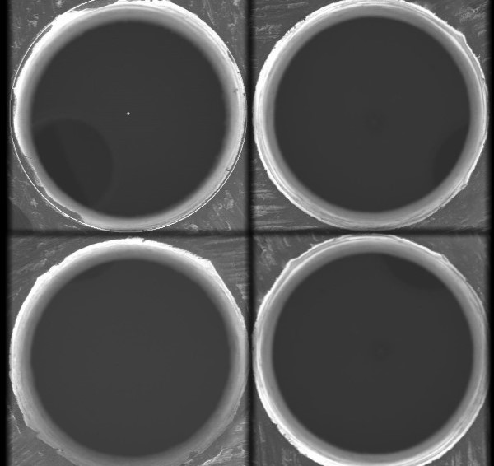

**Fig 1** Picture of a perfectly drilled hole

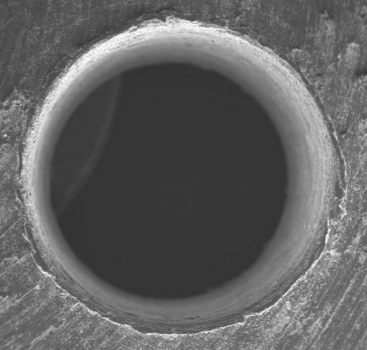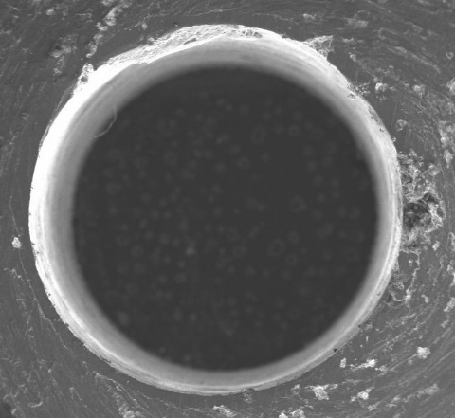

**Fig 2** Occurrence of Delamination & Cracks

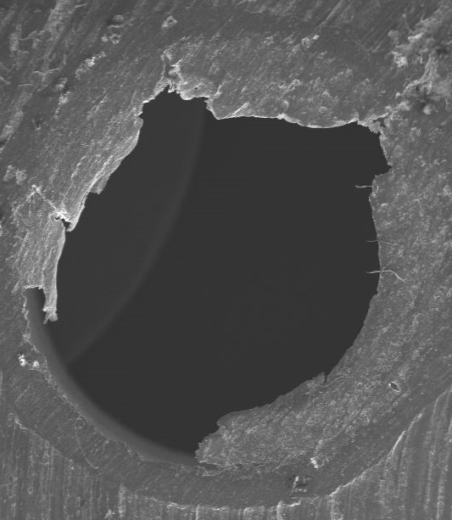

**Fig 3** Picture of an unfinished drill hole

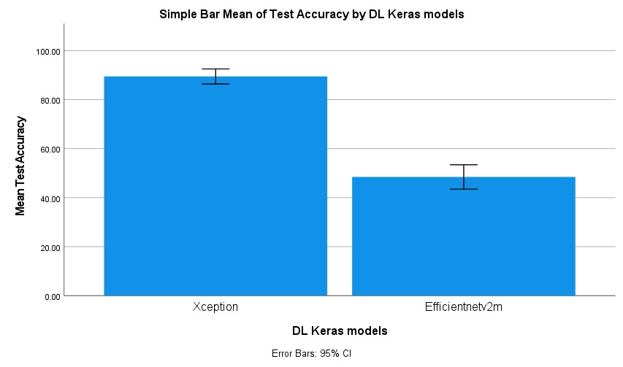

**Fig 4** Comparison of mean test Accuracy , of two surface defect detection models, EfficientV2M at 48% and Xception at 91%